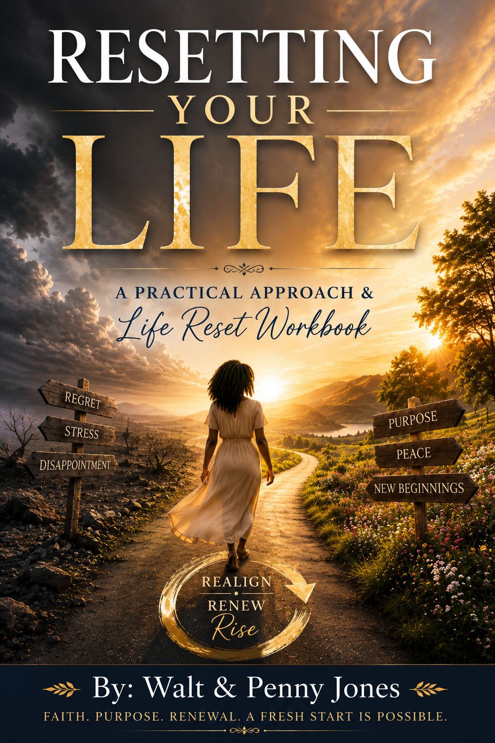

Resetting Your Life
A Practical Approach & Life Reset Workbook

By: Walt & Penny Jones
Resetting Your Life: A Practical Approach

Introduction
Have you ever gone through a season in life where nothing seems to be going the way you hoped? Plans fall apart, stress builds, and it feels like you're constantly trying to catch up but never quite getting there. If that sounds familiar, it might be time for a reset.
Now, when I say "reset," I don't mean throwing everything away or starting over completely. A reset isn't about abandoning your life—it's about realigning it.
We use a process called ADDIER: Assessment, Design, Development, Implementation, Evaluation, and Revision. It's a structured way to improve systems and outcomes. But what if we applied even part of that same process to our personal lives?
I know there are times when we wish we could simply push a button and reset our lives, or even erase and restart a particular moment in our journey. For some of us, that reset button would be worn out from being pressed so many times because of the mistakes, regrets, disappointments, and challenges we have faced. We often look back and wish we could do things differently.
The good news is that God is a God of new beginnings. In the Bible, Jesus encountered Saul, a man who was determined to destroy the church. Yet through a life-changing encounter with Christ, Saul's life was completely transformed, and he later became known as Paul, one of the greatest apostles in history. Jesus didn't just change Saul's direction—He reset his life and gave him a new purpose.
Just as Saul experienced a spiritual reset, there comes a time when each of us must examine our own lives. We must be willing to pause, reflect, and allow God to renew our hearts, minds, and direction. A reset is not about dwelling on the past; it is about embracing God's grace and moving forward into the future He has prepared for us.
Let's start with the first step:

Assessment: Understanding Where You Are
Before you can change anything or grow in any area, you have to take an honest look at where you are. Assessment simply means evaluating what's working and what isn't. In a workplace setting, this might involve surveys, feedback, and data collection. In your personal life, it starts with asking yourself real, honest questions.
"Let us search and try our ways, And turn again to the Lord."
— Lamentations 3:40
What in your life feels off? What causes frustration, pressure, or stress? It could be the people you spend time with. It could be financial strain. It might be that you're trying to take on too much without enough time or energy. Whatever it is, don't ignore it.
Take a moment and write down five things in your life that feel stressful or out of alignment. Be honest with yourself. This list is not for judgment—it's for clarity.
Then, just as importantly, write down five things that are going right in your life. These are your strengths, your blessings, the areas where you're doing well or finding peace.
Why both?
Because a true reset isn't just about fixing what's wrong, it's also about recognizing what's right and building on it. When you can clearly see both sides, you put yourself in a position to make better decisions moving forward. A reset starts with awareness. And awareness begins with assessment.

Section 1: Assessment — Understanding Where You Are
Purpose: Identify what's working and what needs to change.
Exercise 1: Honest Reflection
Take a few quiet moments and answer the following:
• What areas of my life feel overwhelming right now?
• What causes me the most stress day to day?
• Where do I feel out of control?
✍️ Write your thoughts below:
Exercise 2: Identify 5 Stressful Areas
List five areas in your life that feel stressful or out of alignment:
1.
2.
3.
4.
5.
Exercise 3: Identify 5 Positive Areas
Now list five things that are going well in your life:
1.
2.
3.
4.
5.

Design and Development: Creating a Plan for Change
Now let's move into the next phase: Design and Development.
"Commit to the Lord whatever you do, and He will establish your plans."
— Proverbs 16:3 (NIV)
In this part of the process, we take the five areas we identified as stressful and begin to build a plan to address them. Awareness is important, but without action, nothing changes. This is where we become intentional about improving our lives.
Start by looking at each stressful area one at a time and ask: What can I do to make this better?
If one of those areas is financial, then we must take an honest look at our spending habits. If more money is going out than coming in, that's a clear problem. The solution starts with visibility. Pull up your bank statements and track where your money is actually going. You might be surprised at what you find.
From there, begin to develop a spending plan. This plan should help you:
- Pay off bills and reduce debt
- Build savings for the future
- And, if it's part of your values, set aside money to give back, including giving to God
The goal isn't restriction—it's control. You want your money to work for you, not against you.
If another area involves relationships, especially spending time with the wrong people, then it's time to evaluate access. Not everyone should have the same level of influence in your life. You have to be mindful of who you allow closer to you and how much access they have.
There is nothing wrong with setting personal boundaries. Boundaries are healthy. They define how you expect to be treated emotionally and physically. They protect your peace, your time, and your growth. Setting limits doesn't mean you don't care about people, it means you care about your well-being.
Now, let's shift to the five things that are going right in your life. It's easy to focus only on problems, but you cannot ignore what's already working. These areas still require attention. In fact, they require intentional improvement.
Why? Because anything left unattended can eventually decline. If something is going well—whether it's your work ethic, your faith, your relationships, or your personal discipline—you should continue to invest in it. Strengthen it. Grow it. Protect it.
The goal of Design and Development is balance: Fix what's broken. Strengthen what's working. When you do both, you create a more stable and intentional life.

Section 2: Design & Development — Building Your Plan
Purpose: Build a plan to improve weak areas and strengthen strong ones.

Exercise 4: Problem-Solving Plan
Choose your top 3 stressful areas and answer the questions below for each one.

Area #1:
• What is causing this issue?
• What changes can I make?
• What is one action I can start this week?
✍️ Notes:

Area #2:
• What is causing this issue?
• What changes can I make?
• What is one action I can start this week?
✍️ Notes:

Area #3:
• What is causing this issue?
• What changes can I make?
• What is one action I can start this week?
✍️ Notes:

Exercise 5: Financial Check (if applicable)
• Do I know where my money is going?
• Have I reviewed my bank statements recently?
• What can I cut back on?
✍️ Action Step:
Exercise 6: Relationships & Boundaries
• Who has the most influence in my life?
• Are these relationships helping or hurting me?
• What boundaries do I need to set?
✍️ Boundaries I will set:
Exercise 7: Strengthening What's Working
Choose 2 things from your "positive list" and answer:
• How can I grow this area?
• What actions will I take to maintain it?
✍️ Notes:

Implementation: Putting the Plan into Action
Now that we have a plan in place, it's time for the next step: Implementation.
"Faith by itself, if it is not accompanied by action, is dead."
— James 2:17 (NIV)

Implementation is where everything begins to come to life. It's one thing to design a plan, but it's another thing to actually put that plan to work. This is where discipline, consistency, and commitment all come into play.
Take your plan and begin working on it over a period of six to eight weeks. This gives you enough time to build new habits, make adjustments, and start seeing real progress. Change doesn't happen overnight, but steady effort over time will produce results.
During this phase, it's important to stay organized and intentional. You may need to write your plan down and keep it somewhere visible. This serves as a daily reminder of what you are working toward.
Also, track your progress. Ask yourself questions like:
- Am I following the plan I created?
- What improvements am I seeing?
- Where am I struggling or falling short?
Tracking your progress helps you stay accountable. It also allows you to see small wins along the way, which can motivate you to keep going.
Understand that not every day will be perfect. There may be moments when you fall short or feel discouraged. That's part of the process. Implementation is not about perfection, it's about persistence.
As you consistently apply your plan, you will begin to notice changes. Some may be small at first, but over time, those small changes will lead to meaningful transformation.
Implementation is where effort meets action—and action is what leads to results.

Section 3: Implementation — Taking Action
Purpose: Put your plan into motion
Exercise 8: Your 6–8 Week Plan
Write 3–5 actions you will consistently work on:
1.
2.
3.
4.
5.
Exercise 9: Weekly Progress Tracker
Use this template each week to reflect on your progress.
Week #:
• What did I do well this week?
• Where did I struggle?
• What will I improve next week?
✍️ Reflection:
Daily Check-In (Optional)
Prompt
Response
Did I follow my plan today?
YES / NO
One win today:
One thing to improve:

Evaluation: Reflecting
After you have spent six to eight weeks putting your plan into action, it's time to move into the final phases: Evaluation and Revision.

"Examine yourselves to see whether you are in the faith; test yourselves."
— 2 Corinthians 13:5

Evaluation is where you take a step back and honestly review your progress. This is your opportunity to look at what has happened over the past several weeks and measure the results of your effort.
Ask yourself:
- What areas have improved?
- What habits have changed?
- What goals have I made progress towards?
- Where am I still struggling?
This step requires honesty. Not everything will go exactly as planned, and that's okay. The purpose of evaluation is not to criticize yourself, but to understand what is truly working in your life and what is not.
Take time to review the five stressful areas you identified at the beginning. Are they still as stressful? Have they improved? Also, look at the five areas that were already going well. Did you continue to strengthen them, or did they begin to slip?

Section 4: Evaluation — Reviewing Your Progress
Purpose: Measure what has changed after 6–8 weeks.

Exercise 10: Self-Evaluation
• What improvements have I seen?
• What habits have changed?
• Which areas are still difficult?
✍️ Reflection:
Revisit Your Lists
Look back at your original answers from Exercises 2 and 3:
• Are your 5 stressful areas still the same?
• Have any improved?
• Did your positive areas stay strong, or did any begin to slip?
✍️ Notes:

Revision: Adjusting
Once you have evaluated your progress, you move into the final step: Revision.
Revision is about looking back at the 6 to 8 weeks and seeing what was working and what you think you may need to change in your life. This is where you look and see if you still need to change the way things are going. If it is working for you then great; if not, then change the areas. You can always go back to the Development part of the program and see what needs to be added or subtracted. Then implement that part.
Revision is about adjustment, not failure. If something doesn’t work, it simply means you need a better approach. Growth is a continuous cycle, and sometimes you have to revisit earlier steps to move forward more effectively.

Remember
The most important part of this process is to always keep God a part of the plan. Seek guidance, stay grounded in your faith, and trust that your efforts, combined with His direction, will lead you where you need to be.

Now that you have a new plan, try it out again for another 6 to 8 weeks. Keep a journal of your progress, your challenges, and your victories. Over time, you will begin to see not just temporary changes, but lasting transformation in your life.

Section 5: Revision — Adjusting the Plan
Purpose: Refine and improve your approach
Exercise 11: Make Adjustments
• What worked well?
• What didn't work?
• What do I need to change moving forward?
✍️ Notes:
Next Steps Plan
What will I continue doing?
What will I stop doing?
What will I start doing?
Spiritual Reflection
• Have I included God in my plans?
• Am I seeking guidance through prayer?
• What is God leading me to change?
✍️ Reflection:

Final Commitment
Now that you've completed this cycle, it's time to commit to the next one:
• Commit to another 6–8 weeks
• Continue journaling your progress
• Stay consistent and intentional
"For I know the plans I have for you," declares the Lord, "plans to prosper you and not to harm you, plans to give you hope and a future."
— Jeremiah 29:11 (NIV)
✍️ My Commitment Statement:

Resetting Your Life — A Practical Approach & Life Reset Workbook | Written by Walt & Penny Jones

